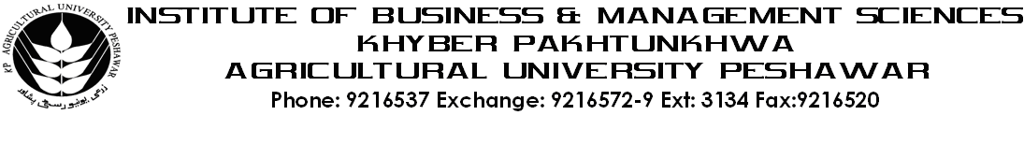
Program: BS (CS)-III
Course Title: Multivariate Calculus
Course Code: MT-401
Session: 2011-2014
Course Hours: 03
Total Weeks: 16
Total Credit Hours: 48
Course Objective
Multivariable Calculus has many applications in Engineering Science as well as in Computer Sciences. It enables the students to use the applications of multivariable functions and to find the area in two and three dimensions.

Week-1
-Introduction to Functions of Several Variables

Week-2
- Partial Differentiation

Week-3-4
- Multiple Integrals
i) -Double Integrals
ii) -Triple Integrals

Week-5
- Line Integrals

Week-6
- Surface Integrals

Week-7
- Use of Green’s Theorem

Week-8
- Use of Stoke’s Theorem

Week-10
- Periodic Functions, Fourier Series

Week-11
- Fourier Series of Functions of any period 2L
Week-12
- Fourier Series of Even and odd functions

Week-13
- Half range Expansions

Week-14
- Fourier Transformation

Week-15
- Laplace Transformation

Week-16
- Z-Transformation

Total Marks: 100

Recommended Books:

1. Calculus by Thomos / Finny 9th Edition
2. Advance Engineering Mathematics by Erwin Kreyzig 8th Edition
3. Mathematical Technique by Dr. Kiramat Hussian Dar
4. Calculus by Swokowski, Olinick, and Pence.

